Central Ohio Area Service Committee Meeting Minutes
22 Jan 2023

Meeting called to order at 2:00 P.M. by: Tammy S
Serenity Prayer recited by: All
Service Prayer read by: All
The Twelve Traditions of Narcotics Anonymous read by: Elizabeth E
The Twelve Concepts for NA Service read by: Kenny W
The Twelfth Concept read by: Deborah C

BACK TO GROUPS:
- Motions
- 2023-01: Motion to remove Kelle A for the position of Writing Steps for Recovery chair for neglect of duties (full motion attached)
- 2023-02: Motion to forgo audit of the area office account as the old area office chair did not work with the finances (full motion attached)
- Nominations for open ASC positions:
  - Vice-Chairperson
  - Activities Chair
  - Newsletter Chairperson
  - Vice-Secretary – Casey V (nomination form attached)
- Nominations for open Ohio Region positions:
  - Public Relations Chair
  - Webmaster
  - OCNA Advisory Committee members #2 and #3

Roll Call: (Apologies to anyone we missed)
- Elizabeth E, GSR Together We Can/Vice Sec Area
- Fred S, GSR Promise is Freedom
- Tammy S, Chair Area
- Mark R, COASCNA Treasurer
- Jeff T, GSR Grateful Not Dead
- Alyce N, GSR Journey Continues
- Byron B, GSR Serenity group
- Dylan P, GSR I Can’t We Can
- Scot H, GSR Aging in Recovery
- Emily T, H&I and Unity day chair/GSR 11th Step Candlelight
- Aaron H, GSR Trust the Literature
- Cody M, Concerned member
- Tahja C, GSR Women in Recovery
- Erika D, Alt GSR Together We Can
- Harold P, GSR Free at Last
- Paul M, GSR Out in Recovery
- Laura P, GSR Never Alone Never Again
- Casey V, GSR Meshuganeh
- Robert S, GSR Animal House
- Lis R, Secretary
- Tracy J, GSR Da Addicts Way Out
- Lenore B, GSR Freedom Through Fellowship
- Jon U, GSR Monday Miracles

Minutes approved:
Minutes for December were tabled for approval at the February meeting

New Group Recognition:
None

New Group Service Representative(s):
Lenore B (Freedom Through Fellowship), Robert S (Animal House)

New Flyer Approval:
None

Brief financial assessment from Treasurer:
Brief Financial Assessment from the Treasurer
Open financial report forms/receipts:
- Check 1178 - ORSCNA - October 2022 Donation - $157.34
- Check 1182 - ORSCNA - November 2022 Donation - $146.80
- Check 1184 – COAONA – December 2022 Office Rent - $250.00
- Check 1185 – Ohio Mutual Insurance – Area Office insurance - $401.00
- Check 1187 – COAONA – January 2023 Office Rent - $250.00
- Check 1188 – Gail B. – New Year’s Eve Budget - $750.00
- Check 1190 - ORSCNA - December 2022 Donation - $572.60
- Check 1193 – Lower Lights Church – ASC rent - $60.00
- Check 1195 – Tammy S. – New Year’s Eve Budget - $750.00

Outstanding checks not cashed and reflected in current balance:
- None

Starting Balance | $5,492.62
Group Donations | $906.13
Donations | $2,277.23
Expenses | $584.59
Ending Balance | $8091.39

Current expenses:
- ORSCNA Donation $181.23
- Area Office phone/internet $100.00
- Area Office rent $250.00
- Tammy S./Printing policies $53.36

Unfinished Business:
- COACNA Policy approval tabled until February ASC meeting
- Motion 2023-01 introduced to remove Kelly A as chair of the Writing Steps for Recovery subcommittee (full motion attached)

Agenda Business:
- Budgets and Check Requests:
  - None
- Elections:
  - Elect Elizabeth E to Office Chair (PASSED 11 yay, 0 nay, 0 abstain)
  - Elect Jeff T to OCNA 39 Fundraising chair (PASSED 9 yay, 2 nay, 1 abstain)
- Motions
  - None

Group Reports:

Groups represented gave a mixture of written and verbal reports. Up to date meeting information is on the website, NACentralOhio.org. Please email any revisions needed due to closing or changes to a meeting to PR at coascna@gmail.com.

Administrative Reports:
Chair Report: (Tammy S.)
January 2023 Chair report
I pray everyone had a wonderful holiday season. I hope you were able to attend and enjoy the 3
awesome events we had in our area since the last time we met. We owe a big thanks to everyone who
worked to make these events a success.
I apologize for not getting the minutes out until this last week. Our secretary had a death in his family,
we can all understand the toll that takes. I took it upon myself to put these minutes together. I emailed a copy with all the attachments, and I have printed the body of it to be available at this meeting. There are areas of the minutes I have missed because I do not remember everything that was discussed. Feel free to contact the Secretary email to be included with the official report. Thank you for your understanding.
Before Covid, we printed thousands of schedules that were made available at ASC or the office. This was very costly, and changes needed to be made almost immediately. We will now print out schedules at the office for your group, or you can print them off yourselves from our area website: nacentralohio.org.
The schedule on the website can also be the answer to being available to those with special needs. It
can be enlarged for easier reading; the phone can read the schedule for hearing impaired and even
translated into other languages.
I have asked our webmaster to include a link to naohio.org to inform our members about events
happening in our region as well as a link to our latest policy on the home page to offer our members up to date guidelines such as what is needed on a flyer to be approved at area.
Finally, it was suggested that we ask our homegroups to host fun events for our Area. Having fun is a
great way to promote unity. I look forward to seeing how creative you can be!
Thank you for the opportunity to serve this committee. I have learned and my recovery has grown so
much.
ILS,
Tammy S. Chair

Vice Chair (OPEN)
NONE

Treasurer: (Mark R)
Good afternoon family, thank you for the opportunity to serve our area. Please continue to announce the following during group announcements:
- COASCNA has set up electronic donations so NA members and groups can donate more easily.
- Interested members and groups can donate with PayPal to coascna.treasurer@gmail.com
- Anyone can set up a PayPal account as long as there is a valid e-mail address and checking account or credit card is associated.
- Please make sure to add a note to indicate which group or person is sending the money so it can be attributed to the correct group.
- Donations made through PayPal will be reduced by the processing fee that COASCNA has to pay to process the donation.

I have nothing specific to report this month. All of the checks cleared since last Area Service and our recorded balance matches the bank balance which is a good thing. I have a number of tasks that I want to complete to organize things better for myself and I should get to those over the next month. Other than that everything is looking good.

The following items will be attached for record and attached to the minutes e-mail.
- Bank Statement for December 2022
- Account Log File
- Financial workbook for January 2023 ASC Meeting
- Group Donations file through January 2023

In loving service,

Mark R., COASCNA Treasurer

Secretary: (Lis R)
Hi, family! Thanks for your patience during this time since my mom’s passing. This year is bound to be a better year, I’m sure of it. In NA, we are about growth and that’s what I’m aiming for this year. Y’all have helped me do it before, and I have no doubt that I’ll get through this again especially with the help of the program. I’m looking forward to some new things for our area to make processes a little more efficient and streamlined, while striving to do better at the tasks at hand as well.
ILS,
Lis R
Regional Committee Member: (Dave M)
i went to RCS Saturday January 14th 2023 , and as i sat there confused and bewildered on how i got myself involved in this level of service again , i took a few notes . Here's what i heard .

Then next World Service Conference is being held April 30th through May 6th 2023 and there are 25 motions in the Conference Agenda Report

here's the link to read the report .. there will be no paper copies for sale https://www.na.org/admin/include/spaw2/uploads/pdf/conference/2023CAR.pdf

here's a tally sheet for the 25 motions https://www.na.org/admin/include/spaw2/uploads/pdf/conference/2023car_tally%20sheet.pdf

if you can print a pdf on your home computer you can use that at your groups

WCNA 38 will be held in Washington DC in 2024 the info link is here , if you subscribe the committee will auto update you by email with registration and hotel updates
Information about the World Convention of Narcotics Anonymous

Information about the World Convention of Narcotics Anonymous

on other news in our region , a couple of the areas of the region are no longer meeting as an area and the groups within those areas have either folded , are going on without participating in the service structure of an area , or have joined other areas . Finally Free Area ( Mansfield and surrounding ) and Northwest Ohio Area ( Lima -Findlay and surrounding )

OCNA 39 will be held in Columbus https://ocna39.naohio.org/

register early , purchase banquet tickets , and book a room if your planning on staying at the hotel

I did reach out to Kelli and left a message , but I procrastinated that action until Saturday 14th ... then my phone died , so she did call me back and my phone was off ., so i have not talked to her this month .
No excuses , I just didn't do it.

Also in the last month I had a battle with Covid-19 and Dylan and I wasn't able to connect to talk about RCM and RCMA responsibilities and formulate a plan of action . Then the Saturday of region I went there alone.... AND That's when i realized I really don't find that I am the right person for the job of RCM .... I've had that positions several times in the past and i feel with all the new technology with webinars , power point presentations , web chats , zooms , slacks , and all that other tech stuff .. im far underqualified as an RCM these days . I would be doing this area a disservice if I continued .

the next regional meeting will be held in Milan Ohio April 1st and 2nd https://wordpress.naohio.org/wp-content/uploads/2023/01/ORSCNA_RegionalMeeting_SBASCNA_20230401.pdf

and that brings me to the final note in this report

April 1st conflicts with another commitment i have , which is to my homegroup .... the homegroup anniversary is that same day and i will not be able to attend the RSC in April and serve the homegroup at the same time and since the April RSC is the last regional meeting in the fiscal year , I WILL BE STEPPING DOWN .... sorry to let anyone down...

in loving service

Dave M
formerly stand in RCM

Subcommittee Reports:
Activities Chair (Open):
None

Convention Committee: (Kenny W)
Hello family,
The convention committee's last meeting was January 14th. We discussed the results of the shindig / speaker Jam at the host hotel. This was a very successful event / fundraiser.
COACNA raised a profit of $1245.52

There was a lot of the discussion about sub-committees getting a calendar together to schedule their upcoming events in advance. We Believe that proper planning prevents piss poor . We did have a registration price increase starting January 15th we will have options on the flyer for the person who registers, they will be able select their entree meal. We are also looking into having the option to pay for your registration through electronic apps such as PayPal, square or cashapp, there's still discussion about this. Coacna bank statement, treasurer workbook will be emailed . I will also be emailing the coacna policy, for the approval of the area. Our next meeting will be February 4th at 1:00pm location will be determined, could not get into the library on that day. Please excuse me in my absence, I can't make it to the meeting today.

ILS
Kenny W.
SERVING WITH PURPOSE

Area Service Office:
Good afternoon family, we have been selling literature, answering the phones, connecting members to groups and resources, and provide other services to members and groups in our area. Our subcommittee will be meeting the first Sunday of the month at 4PM. We will continue to a hybrid meeting. The physical location of the meeting is changing to the Central Ohio Area Service Office at 1313 E Broad St, Columbus, OH 43205. Here are some updated statistics from the month of November 2022:
- Number of sales: 26
- Total sales dollars: $2,342.55
- Month ending bank account balance: $5,496.63
- Inventory: $5,230.90
- Number of phone calls: 143
We wanted to thank our area, groups, and individuals as we work through developing processes to better serve our area. We wanted to update you on the following:

- We now have functioning wi-fi at the service office.
- We are working on updating the policy for the service office and will bring to ASC when completed.
- We are working to remove all old and unnecessary equipment from the service office. We are making sure we have extracted any important old files off any computer equipment in the office.
- At our most recent subcommittee meeting we decided by consensus to reimburse our area for the cost of the computer equipment approved in August 2022. Our treasurer will be providing a check of $1,374.72 to our area service treasurer. We decided to do this because we had funds in excess of our prudent reserve and wanted to make sure those dollars could be used to carry the message.
- NAWS is updating it literature pricing in January 2023. The only items that the service office had to adjust pricing on is book length literature and key tags. NAWS printing costs have increased 30% in the past year. The items with updated pricing are included in this report and now adhere with service office policy. We did our best to minimize price increase to our basic text, Narcotics Anonymous.
  - 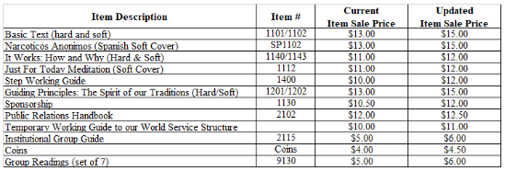
- We are in need of additional service office volunteers and we ask that you please announce at your groups. Service office volunteer shifts are flexible. We can accommodate most reasonable scheduling opportunities.
- We are collecting information to restart the Clean Connections and Rides to Recovery programs in February 2023. We encourage all member to consider signing up for either program and announce the programs at their home group or meetings they attend regularly. A sign up sheet that can be used to collect volunteers will be sent to the secretary for inclusion with the minutes.
  - Clean Connections is a temporary contact program for the Central Ohio Area of Narcotics Anonymous. Addicts new to recovery in the community or nearing release from facilities and institutions can experience feelings of fear about attending meetings regularly. Many of us can empathize with this fear and worry that they won’t find the support to keep their recovery going. We want to connect newly recovering or released addicts with members of Narcotics Anonymous. Shortly after receiving a request for help, an NA volunteer will contact the addict. In those first critical days, the temporary NA contact will potentially meet the addict at a variety of NA meetings, make introductions to other members of Narcotics Anonymous, and share his/her experience of recovery as experienced through the Narcotics Anonymous program.
  - Rides for Recovery creatively enough is a ride program for the Central Ohio Area of Narcotics Anonymous. Addicts new to recovery in the community or nearing release from facilities and institutions can experience difficulties obtaining transportation to NA meetings. We want to connect newly recovering or released addicts with members of Narcotics Anonymous who can give them rides to NA meetings. Shortly after receiving a request for help, the program coordinator will contact the addict. The program coordinator will attempt to connect the addict with a volunteer who can offer them a ride to the meeting. These ride offers will be offered for a limited time and the addict requesting help can be asked to meet the volunteer at a location of the volunteer’s choosing.

ILS,
Elizabeth E., Service Office Vice-Chairperson
Janet B., Service Office Treasurer

Hospital and Institution (Emily T.):
Hello family,

The H&I Subcommittee is doing well. We continue to need support at our treatment center meetings. I won’t repeat what I said last month, but GSRs, please announce the existence of H&I service opportunities at your next business meeting and if you have home group members who are interested in getting involved, they can come to our next meeting.

We are working on an April fundraiser and plan to have a location, time, specifics, and flier next month. Stay tuned.

Our next subcommittee meeting will take place on February 12th at 2pm at the Northside Branch of the public library (1423 North High) in Meeting Room 1. This is a change from our typical day of the first Monday of the month. It is posted on the website. This will be an in person meeting only. Please note that PR will be meeting in the same location from 1p - 2pm right before us.

See you there.

In loving service,

- Emily

Newsletter (Open):
None

Outreach (Bekki M):
Hi Family,
Outreach is compiling a list of the scheduled meetings in our area and seeing which are represented at ASC each month. We're gathering the meetings' GSR contact info of those wanting to share it. We plan to visit the meetings not coming to ASC to see how we may be of service to them. If you are interested in providing GSR contact info for a meeting, please email outreach.coascna@gmail.com with that. If we may be of service in any other ways, please also let us know that.
Hugs,
Bekki M.

Public Relations: (Paul M.)
Hello Family,
Thank you for allowing us to be of service! (I may not be able to attend ASC today. It’s now 10:40am on Sunday 01/22/23 and there is lots of snow falling, so it depends on how the roads are.)
In loving service,
Paul M, PR Chair
614-745-7530

Activities/info since last ASC meeting
- Please extend a big THANK YOU to Chris H. and Jarrod G. for getting updates from Groups about meeting changes during the holidays, and for keeping the website up to date.
- To get info on WCNA 38 (World Convention of NA) in Washington, DC in August 2024, go to www.na.org/subscribe. You can sign up for SPAD (Spiritual Principle A Day), JFT (Just For Today) along with NA News.
- CAR/CAT information on Facebook
  - See the public facing page RD Alnwfl to get info on the WSC motions
- Online CAR/CAT workshop
- 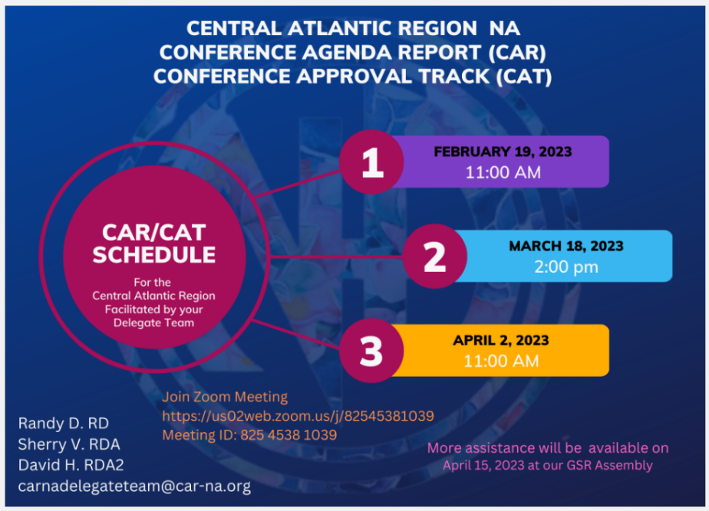
- Groups are encouraged to review meeting information on the website to confirm that all information is accurate, including the virtual meeting link and passcode (if any). Send all meeting changes to COASCNA@gmail.com . It is our responsibility to make sure that addicts seeking recovery can trust the meeting information on our website, and PR needs the help of all groups and individual members to make sure that meeting information is up to date. This information also feeds into NA.org, and into the phone number 844-991-2962 and Facebook ArchSearch where you can search for meetings.
- Fliers approved at Area should be sent to COASCNA@gmail.com as soon as possible. If we wait until the minutes come out, there will be a long delay.
- On Saturday 01/07/23 the PR Chair met with H&I Chair Emily T., ASC Chair Tammy K., and two other trusted servants for a Unity Day wrap up meeting.
  - Emily T. was the chair of the Unity Day subcommittee last year. Unity Day was in September, 2022. A big shout out to Emily for all her efforts!
  - The chairs of PR and Outreach, and other trusted servants, went to every meeting in COAONA prior to Unity Day and provided each group with a Guiding Principles book. At Unity Day, groups and individuals shared what ASC is doing right and what it could be doing better. On 01/07/23 the Unity Day subcommittee reviewed the feedback from groups and proposed next steps. Emily T. will be providing a report on that.
- On Sunday 01/08/23 we had our monthly PR Subcommittee meeting. Please consider joining us! We usually meet on the first Sunday of the month at 1pm at the Northside Branch of Columbus Library, at 1423 N. High Street. See the Events tab of our website nacentralohio.org for details!
  - The H&I subcommittee meets right after us, in the same room, at 2pm. Come for both meetings!
- On Monday 01/09/23 we presented to nearly a dozen 4th year medical students at OSU’s College of Medicine.
  - 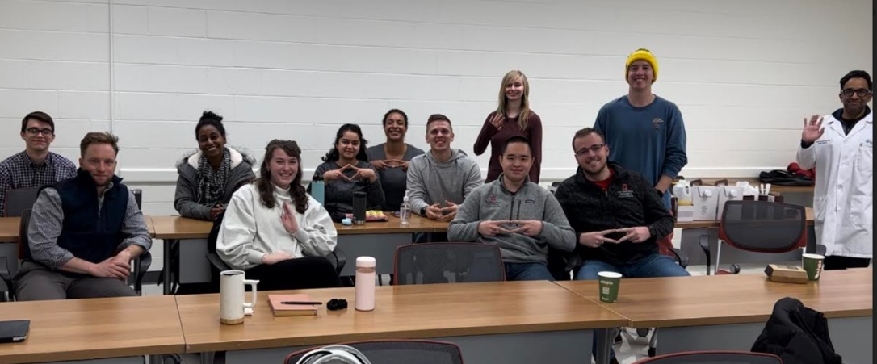
  - We are in the 4th year of doing these presentations, and to date have reached over 700 4th year students and faculty who go on to practice family medicine, surgery, psychiatry, and medical specialties.
    - For the past three years we have participated in a yearly opioid panel presentation to 2nd year med students and their faculty. This has reached over 600 people, mostly medical school students.
    - Many of the 2nd and 4th year medical students choose to attend two open NA meetings to complete their coursework.
  - To see a heartfelt “thanks” from the Med School course director to COAONA, go to https://youtu.be/6X9kD0jO0Dk
    - Other Areas and Regions have used this video and other ESH shared by COAONA PR. One trusted servant in NYC wrote, “I totally used these videos [and photos] to get an upcoming presentation at NYC to a class of addiction psychiatrists in March of 2023!”
- Website stats
  - There were 2,616 visitors in June, who viewed 8,730 pages.
  - There were 2,903 visitors in July (11% increase over June), who viewed 10,217 pages.
  - There were 3,241 visitors in August (11.6% increase over July), who viewed 10,517 pages
  - There were 3,843 visitors in September (18.5% increase over August), who viewed 10,737 pages
  - There were 4,074 visitors in October (6% increase over September), who viewed 10,937 pages
  - There were 3,556 visitors in November (a 12.8% decrease over October, but still a 36% increase over June 2022) who viewed 9,993 pages.
  - There were 3,346 visitors in December. This is a 6% decrease over November, but still a 31% increase over June. Visitors viewed 9,139 pages.
  - In calendar year 2022 (January – December) we had 37,433 visitors who viewed 118,708 pages.
- Chair and Vice Chair of PR, along with vice Chair of H&I, periodically meet virtually with the ODRC (Ohio Department of Rehabilitation and Corrections) to discuss continued rollout of materials directly to the tablets of 45,000 incarcerated people in ODRC facilities. IPs have been available on prison-issued tablets since January, 2021.
  - As a reminder, these materials are made available to the incarcerated free of charge; they do not need to download the materials from a kiosk since they are automatically added directly to their tablets.
    - Ten IPs have been added in English and Spanish, for a total of 15 IPs
    - The audio version of the 5th edition of the Basic Text, in English and Spanish
    - Two videos made by our Area H&I subcommittee
    - Two videos made by our Area PR subcommittee
    - Audio speakers files from WCNA
  - We are exploring options for ODRC to do what California DOC does, which is connect all its facilities to the Sunday Unity Speaker at the WCNA 38 (The 38th World Convention of NA). WCNA is Thursday, August 29 – Sunday, September 1, 2024.
  - ODRC will buy NA’s Reaching Out magazine subscriptions from NAWS. NAWS will ship multiple copies of RO to ODRC institutions in the coming months.
  - We are slowly streamlining the process for NA trusted servants to get clearance to go into ODRC facilities. Our goal is that by the end of 2023 there will be a standard online application process, and that one application will cover all facilities in Ohio.
- We’re helping other Areas and Regions get NA literature on prison tablets.
  - On 12/18/22 we had another meeting with NA trusted servants from Northern Alabama. The Alabama DOC is interested in providing NA eLit, but has not yet set up a meeting with the Northern Alabama trusted servants.
  - The Northern California Region of NA contacted us for information and guidance. They are now confident that they can get eLit on prison tablets, based on the resources we provided. They may set up a meeting between California NA trusted servants, the CDCR (California Department of Corrections and Rehabilitation), and ODRC to gather more information. The CDCR has a prison population of over 100,000.
    - January update: We are in regular contact with NorCal NA PR and H&I to give ESH. NorCal is optimistic that they will have NA eLit on approximately 90,000 tablets by the end of January 2023. We have a meeting with NorCal and the CDCR on Monday, 01/23/23.
  - We have been in regular contact with trusted servants in Florida, Maine, Georgia and Virginia to share ESH and resources.
  - On Thursday 01/19/23, David B. from the Granite State Area of NA (in New Hampshire) contacted us to get ESH on eLit for prions tablets
    - January update: Trusted servants in Florida believe they are very close to an agreement with the Florida DOC and NAWS, to provide NA IPs and other resources directly on the tablets of Florida’s prison population
- Get a list of nearby meetings texted to your phone! REMINDER: Text any zip code to 844-991-2962, wait about 5 seconds, and then you’ll get a list of upcoming meeting based on that zip code. PR will send this info to the Facebook newsletter.
  - Meetings are returned based on info in the BMLT (Basic Meeting List Toolbox). It is soooooo important that we keep meeting information up to date so that addicts seeking recovery can find us, and so that members of the community who come to observe open meetings see that we are a reliable program of recovery. All meeting updates need to be sent to COASCNA@gmail.com
- Get meeting information from Facebook Messenger! NEW: In Facebook Messenger, look up Archsearch and text them a zip code. Same as with the phone number above, a list of meetings will be returned, and possibly additional info like a helpline number and a link for virtual meetings.
We have tabling space in the Short North. As reported in June 2022, we met with Zac Boyer from Stonewall Union. He gave us verbal permission to set up a table outside of the Center at 4th and High. On 08/19/22 we received written permission from Mr. Boyer to set up a table outside of the Center. Currently we do not have enough volunteers to make use of this awesome opportunity!
Writing Steps for Recovery: (Kelle A.)
January 22, 2023
Greetings all,
Our vice-chair was planning to attend today but is unable to attend due to weather and driving conditions as she lives an hour north.
Regarding our committee’s irregular attendance at ASC, I would like to say that we are looking for someone who would like to be involved in what we are doing at WSR that can be more present and represent us in person at this service meeting. When this body met on zoom and hybrid, we were present monthly – and during discussions about moving to in person only, I raised concerns about our attendance based on our committee’s availability and personal locations. So, if you know of anyone who would like to be involved in what we are doing that would be available to attend ASC, please send them our way. Until then, please feel free to call or email me with any questions you may have, and I am happy to answer them. Or you may attend our monthly meetings committee meetings which are held on zoom, the second Thursday of the month at 5:30 p.m. – the link is listed on the website under the WSR tab with the information.
Dave reached out to me last week, following last month’s ASC. When I followed up with him, returning his call, we spoke briefly about the committee and ASC. Although he had no specific questions for me to answer, he shared with me that he had volunteered to call me to check in.
As for our committee, we have successfully picked up all of our things from the area office and are now just picking up mail there.
We are rewriting some or our policy to best reflect the changes that we feel will best serve the needs of the addicts writing to us who are incarcerated.
We are current on mail. We have successfully sent out over 200 initial response packets to those incarcerated who have reached out to us, which includes a welcome letter detailing what we do and don’t do, a resource sheet for while you are inside and when you are released, and a first assignment which is part of a process that is meant to be completed before being assigned to a Step Guide. We have received 32 first assignments back so far, and 6 second assignments. Once we receive back third assignments, which could happen at any time, we will be assigning our Step Guides.
We are still seeking Step Guides, especially men. We continue to look for people, so if you have 2 years clean and have worked the steps with a sponsor, or are near completion – please fill out the form and send it in (which you can also do on the website under our tab).
We really look forward to continuing in this process, and involving more people in what we are doing. Again, feel free to reach out with any questions – we also look forward to hearing from you!
In loving service,
kelle a.

Ad-hoc Reports:
Addithon: (Brenda M)
Addithon 2022 Report,
December 24th and 25th
The first day of the event started off a little rocky the water pipes had frozen due the -0 below temperature and the snow storm. Our vice chair Gail B was sick and had to leave to go home. Let’s continue to pray for her.
However we did get started a little late due to the frozen water pipes. Addithon 2022
It went really well for that day and also the following day there was plenty of food donated and purchased for the event. I want to thank everyone for stepping up and been of service and for the food donations. We shopped spent a total of $782.00 on food snacks facility rental fee and supplies in which receipts was emailed to Mark R our treasurer.
Also the seventh tradition was collected in which was a total of $118.00 in which I do have a money order for this.
Again thank you to everyone for coming out and joining us those of you who did service work.
In loving service
Brenda M Addithon Chair
Gail B V Chair
Elizabeth E

New Year’s Eve: (Gail B)
None

Unity Day: (Emily T)
None

Audits:
COASCNA Audit 2022 (July-November)

Hi Family,

We completed the COASCNA general fund audit for July, 2022 – November, 2022 on January 6, 2023. The audit was conducted by Area Treasurer, Mark R. and Area Vice-Treasurer, Janet W. The outgoing Treasurer, Jarrod G. and Area Chairperson, Tammy S. were there as well. All of the data needed to conduct the audit had been saved on our Google drive by Jarrod. This was immensely helpful and we can keep this data as long as needed online without it getting misplaced.

We followed the ORSCNA policy outline as general guidance for the audit. Their policy is broken into 3 parts. A summary is provided here of the findings for each part, and the detail is included in the attached COASCNA Account Log Audit file.

- Reconcile all bank statements (along with all cancelled checks and deposit records) against the check register. Balance the check register against each monthly bank statement to verify the account balance.
Findings: All transactions from the Fifth-Third account statements were entered correctly into the Account Log. The Account Log matches the bank statements and the November ending balance was confirmed.
- Verify that all receipts written from the receipt book total what monies came in and that those monies equal the amounts deposited to the checking account.
Findings: Jarrod provided images for group donations made at ASC, images for all of the PayPal donations as well as images of receipts written by the Area Office workers for all donations from groups. All of those matched with entries in the Account Log and Treasurer’s Workbook and had deposit receipts where expected except for 1 item.
- In October there was a donation of $100.00 from the Southside Text Discussion group, but there was no receipt written. We couldn’t determine whether the donation was made at the office or at the ASC meeting. It was recorded properly in the Treasurer’s Workbook and included properly in the deposit recorded in the Account Log.
- Verify that all disbursements of funds are accounted for with valid receipts & financial forms and were appropriate expenditures.
Findings: Correct receipts were returned for all but 3 of the checks written during the time period to addicts/subcommittees for service activities. See the table below for specific details. In order to maintain accountability and ensure NA funds are being used responsibly, a financial report form with receipts should always be returned to the Treasurer after completion of an event/activity or when given money from the ASC.
Check # | Date | Amount | Payee/Description
1162 | 7/17/22 | $120.00 | Lower Lights Christian Church – for Area Service rent
1167 | 8/21/22 | $250.00 | Randy Burchfield – for Sept. 2022 office rent
1181 | 10/16/22 | $60.00 | Lower Lights Christian Church – for Area Service rent

In loving service,

Mark R. & Janet W.

OCNA FUNDRAISER: (OPEN)
Interested parties can reach out to Jeff T.

ARCHIVES: (Casey V)
Good afternoon Family,
The Archives ad-hoc committee is doing well! We met this month and were able to take several steps forward. We recycled non-valuable documents that did not contain sensitive information (such as group reports and nomination forms). Physical documents that do contain sensitive information will be shredded. We devised a strategy for scanning documents into digital format, utilizing Google Drive for ease of access and uploading for each committee member.
The digital files obtained from the area office contained some of the missing information we needed, specifically from 2005 to 2017. Committee member Mark R also provided his digital files that will help fill in missing months and hopefully 2017 to present. At this time, the committee is working on scanning the physical documents into electronic format. We also are sorting through the existing digital files for their historical value.
Our next meeting is not yet scheduled, though it will likely be a Sunday afternoon at the main branch of the Columbus Public library. We continue to have no need for financial support. At this time we do not have an updated completion date goal, though it will likely be before summer 2023. As always, please feel free to reach out to me if you are interested in helping to preserve this area’s history!
In loving service,
Casey V.
Archives Ad-Hoc Committee Chairperson
330-523-8924
Nominations to Fill Open ASC Positions:
Current Open Positions:
- Vice-Chairperson – No nominations made
- Newsletter Chair – No nominations made
- Area Office Chair – Elizabeth E (see attachment)
- OCNA Fundraising Chair – Jeff T (see attachment)
- Vice-Secretary – Casey V (see attachment)

Nominations to Fill Open RSC Positions:
Current Open Positions:
- H&I Chairperson – No nominations made
- Public Relations Chairperson – No nominations made
- OCNA Advisory Member #3 – No nominations made

Sharing Session:
None

Unplanned Business:
- 2023-01: Motion to remove Kelle A for the position of Writing Steps for Recovery chair for neglect of duties (full motion attached)
- 2023-02: Motion to forgo audit of the area office account as the old area office chair did not work with the finances (full motion attached)

Pre-Agenda Business:
None

Adjournment:
Chair Adjourned the meeting with a moment of silence followed by the serenity prayer

Next ASC meeting: 16 October 2022 @ 2pm EST
Central Ohio Area Service Committee of Narcotics Anonymous Trusted Servants
Administrative Committee
Chairperson | Tammy S. | 614-323-4681 | tammyk054@gmail.com
Vice-Chairperson | ***OPEN***
Secretary | Lis R. | 419-231-2204 | lkregula@gmail.com
Vice-Secretary | Elizabeth E. | 614-893-1562 | elizabetheastman1967@gmail.com
Treasurer | Jarrod G. | 614-506-5690 | jwgrph@gmail.com
Vice-Treasurer | Janet W. | 614-406-0768 | jbogin3@gmail.com
Regional Committee Member | ***OPEN***
Regional Committee Member Alternate | ***OPEN***
Subcommittee Chairpersons
Activities Chairperson | ***OPEN***
Area Office Chairperson | Craig F. | 601-331-1440 | Craigfrierson@gmail.com
COACNA 30 Chairperson | Shadena C. | 614-902-9139 | coacna30convention@gmail.com
Hospitals & Institutions Chairperson | Emily T. | 937-266-8383 | emilydealoia@gmail.com
Newsletter Chairperson | ***OPEN***
Outreach Chairperson | Shadena C. | 614-902-9139 | outreach.coascna@gmail.com
Public Relations Chairperson | Paul M. | 614-745-7530 | cbusnapaulm@gmail.com
Writing Steps in Recovery Chairperson | Kelle A. | 614-738-1673 | kellealavi@gmail.com

